**CEA MASLD Figures and Tables 2/18/2025**

**Table 1**: Model Input Parameters

|  |  |  |
| --- | --- | --- |
| **Variable** | **Base-Case Value and Range** | **Reference** |
|  |  |  |
|  |  |  |
|  |  |  |

**Table 2**: Cost-effectiveness of HCC screening in the base-case analysis and subgroups by age and sex.

|  |  |  |  |  |  |
| --- | --- | --- | --- | --- | --- |
|  | Average overall cost | Incremental Cost | Average Overall QALYs | Incremental QUALYs | Cost per incremental QALY |
| **Overall** |  |  |  |  |  |
| Control |  |  |  |  |  |
| Intervention |  |  |  |  |  |
| **Male** |  |  |  |  |  |
| Control |  | 0.00 |  | 0.00 | N/A |
| Intervention |  |  |  |  |  |
| **Age ≥65** |  |  |  |  |  |
| Control |  | 0.00 |  | 0.00 | N/A |
| Intervention |  |  |  |  |  |

**Figure 1:** Health state transitions of Markov model.

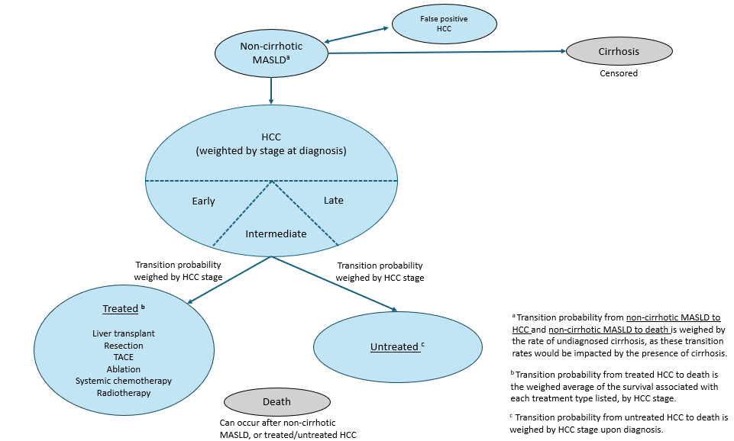

**ONE-WAY SENSITIVITY ANALYSIS**

**Figure 2:** Tornado diagram for sensitivity analyses testing cost effectiveness across a range of values for the following variables.

*X-axis: NMB*

*Net Monetary Benefit or ICER? Use NMB because ICER interpretation is convoluted without knowledge of the sign of incr cost and incr utility (*[Calculating and Interpreting ICERs and Net Benefit | PharmacoEconomics](https://link.springer.com/article/10.1007/s40273-020-00914-6)) *NOTE: By plotting NMB rather than ICER, we will need to choose one WTP value. Choose 100,000 or 150,000 and use the other as sensitivity analysis.*

1. Annual HCC incidence in non-cirrhotic MASLD
2. Annual HCC incidence in undiagnosed cirrhotic MASLD
3. Annual cirrhosis incidence
4. Percent of undiagnosed cirrhosis
5. Annual death rate in MASLD patients
6. Annual death rate in undiagnosed cirrhotic MASLD patients
7. Annual death rate in patients with treated HCC (+/-25% from the value weighed across treatment types)
   1. Early
   2. Intermediate
   3. Late
8. Annual death rate in patients with untreated HCC (+/-25% from the base case value)
   1. Early
   2. Intermediate
   3. Late
9. False positive rate of HCC screening
10. Probability of receiving treatment by HCC stage
11. Probability of being untreated by HCC stage
12. All costs and utilities

Example from Dr. Jim Huang’s manuscript:

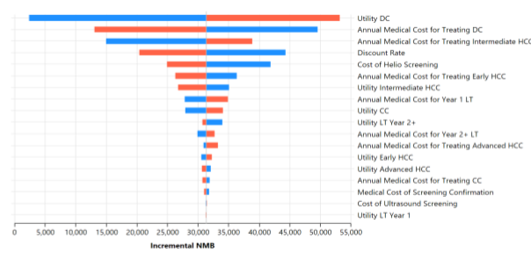

**Figure 3:** Two-parameter visualization of cost-effectiveness depending on proportion of HCC cases diagnosed early vs. late. (Using the base-case values for all over variables)

*X-axis: Percent diagnosed early*

*Y-axis: Percent diagnosed late*

*Color region grey for cost-effective, and black for not cost-effective.*

Example from Parikh 2021: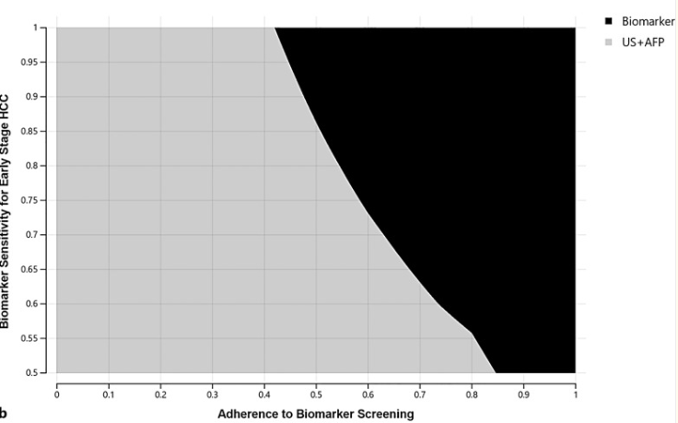

**Figure 4:** Threshold analysis of screening adherence rate.

X-axis: Screening adherence rate (0-100%)

Y-axis: ICER

**PROBABILISTIC SENSITIVITY ANALYSIS**

**Figure 5:** Scatterplot of incremental utility and cost based on the probabilistic sensitivity analysis (100,000 runs choosing values randomly in range for all variables).

*X-axis: incremental utility*

*Y-axis: incremental cost*

*Include a line showing the cost effectiveness threshold at a WTP threshold of 100,000 and 150,000.*

Example from Dr. Jim Huang’s manuscript:

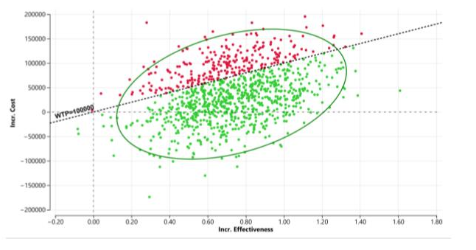

**Figure 6:** Cost-effectiveness acceptability curve based on the probabilistic sensitivity analysis

*X-axis: Willingness to pay threshold*

*Y-axis: Probability of intervention being cost effective*

Example from Parikh 2021:

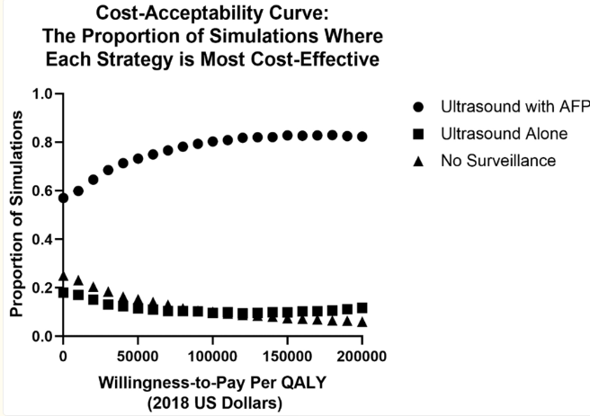

***SUBGROUP SENSITIVITY ANALYSIS BY AGE AND SEX***

**Figures X:** Sensitivity analyses as in figures 2, 4, 5, for a starting cohort of (A) all male patients and (B) all patients ≥65 years old.

*We will adjust the transition rate of MASLD to HCC, MASLD to cirrhosis (censored), and MASLD to death according to the age and sex of the starting cohort.*